**Message from Georgie**

**The aim.**

S**uccessive groups of Scottish teachers work with teachers and mentors responsible for supporting and training teachers, in order to raise educational standards in camps for displaced people. Rwanda benefits, but so does Scotland. Visiting teachers face challenges, some familiar, but of a quite different order. The first weeks were about familiarisation, observation and discussion with teachers,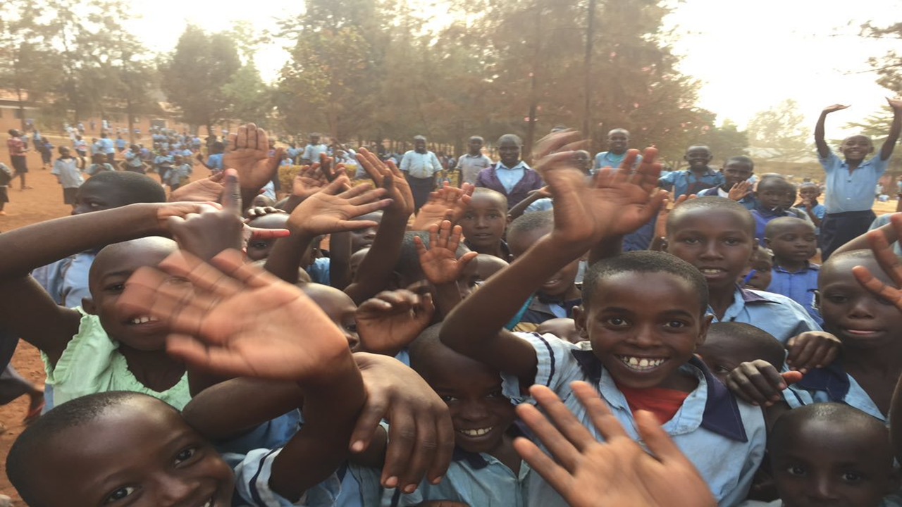 pupils and mentors, to identify the most important issues, then to design and deliver training.**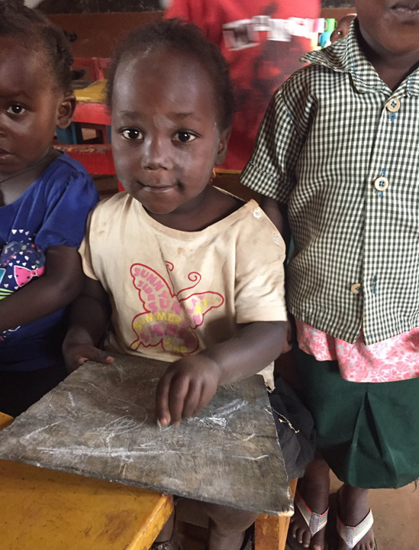

**First impressions**

First impressions were overwhelming, even though they had been prepared. Georgie reported "Most lessons were chalk and talk, teachers beat children with sticks, twisted ears and smacked their heads." She went with Ross (another young Scottish teacher) to a nursery. "A tiny classroom full of maybe 80 children, who were all poorly. The young nursery teacher was teaching them how to count to 25, but didn't know how to count very well himself. He asked what he should do about the health of the children. ““Most secondary teachers we met had some sort of degree but very poor wages and often poor motivation.” Classes could be mixed in age, because pupils were set according to educational progress “We saw a man of about twenty, in a class with much younger children”.

**What she did with your help.**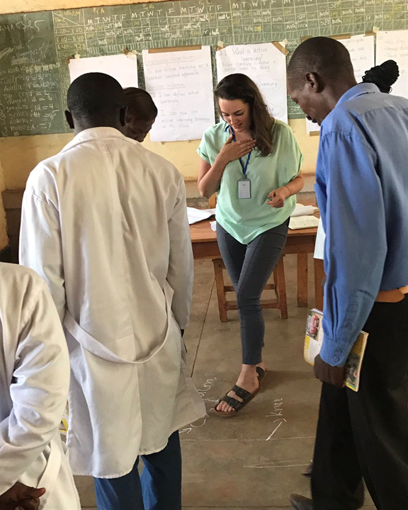

The second stage was design and preparation of training sessions. "We concentrated on active learning techniques, we worked at home until midnight preparing. We got up at 5am to deliver training to groups of 15-30 teachers all day. We then did the same sessions at another school the following day. Then we started all over again with more preparation.”

“I used the teachers as if they were pupils, just to give practical examples of what they could do in their classrooms. We made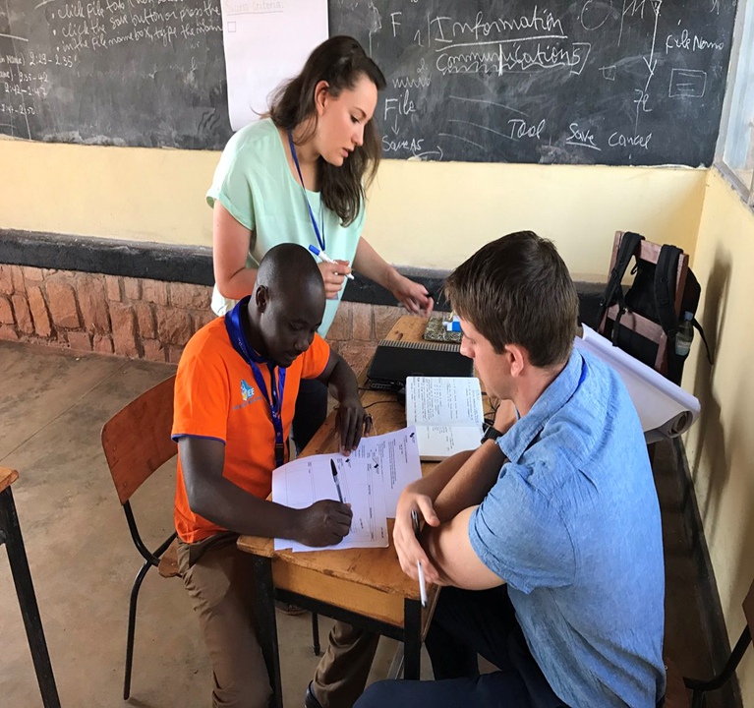 human number lines, line ups (get in order of age, birthdays, months, height, alphabetical order of first and last names etc.). I made up what I called “The group on the ground” we used the floor to draw maps, draw round each other, make diagrams of plants or the periodic table. They worked in groups to label it and then used it to answer teacher or student led questions like ‘stand on the part of the body that pumps blood around’.”

“We delivered training on how to teach pupils with additional languages (as the camp children mostly don’t speak English or Kinyarwanda), barriers to learning (all the things that face these children before they can even think about learning; hunger, anxiety, disabilities, lack of sleep, fear and trauma. We discussed how to tackle some of these. We introduced ideas about parental engagement (attachment theory, exploring reasons why parents may not be engaged with the school community and ways in which they can try to overcome these). "The day after the teams training with Mahama Camp mentors, they organised a parents meeting at the camp and over 800 parents showed up.”

“In our final week we returned to Kigali and delivered 2 days of training to a group of around 11 mentors and then did the same again with another group over the next 2 days. On our final day these groups presented back the main points from each training session, to the rest of the mentor group. The idea being that mentors take what they have learnt and repeat it in their schools, with their teachers over the course of the year.” One of the mentors commented “the team placed in my district was so courageous, they could adapt themselves to a range of situations. They were so much positive and supportive to the schools and community where they lived”

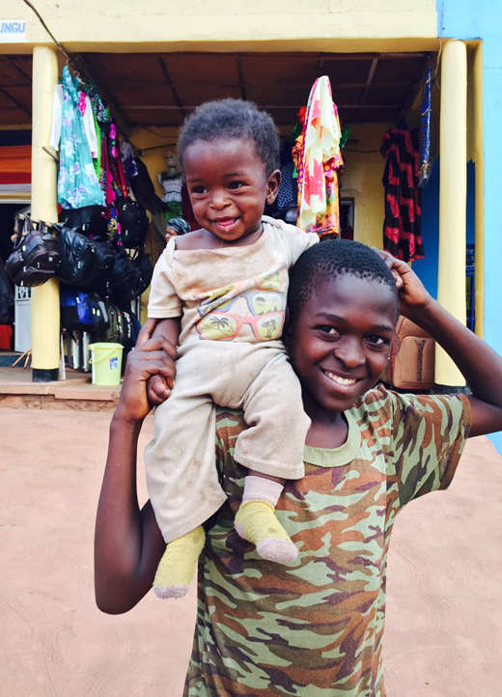

**What she brought back to Scotland**

“We observed strong values and sense of community in Rwanda. Mothers hand their babies to strangers on the bus if they need soothing, people walk miles to fill up water tanks for their neighbours, they feed each other the last of their beans, rice and cassava. They accommodated us muzungus. Ensuring we got a fair price for motos, we weren’t fleeced at the market and got our nya nyas (tomatoes) and vocas (avocados) for 20p. They ensured we knew where we were going or what bus to get on."

“It made me think about building that sense of community around and within my own classroom in Stirling. Developing shared values, through open discussion, so that children feel empowered to speak up for what they think is right and know they will be listened to”.

"I want the pupils in my classes to be the Emmeline Pankhurst’s, Erica Mackey’s, Mohammad Yunus’s and Gino Strada’s of their time! To be kind and thoughtful about the world, but not afraid to challenge. In a time when our future is so uncertain, is is crucial to instil strong values in our children.”

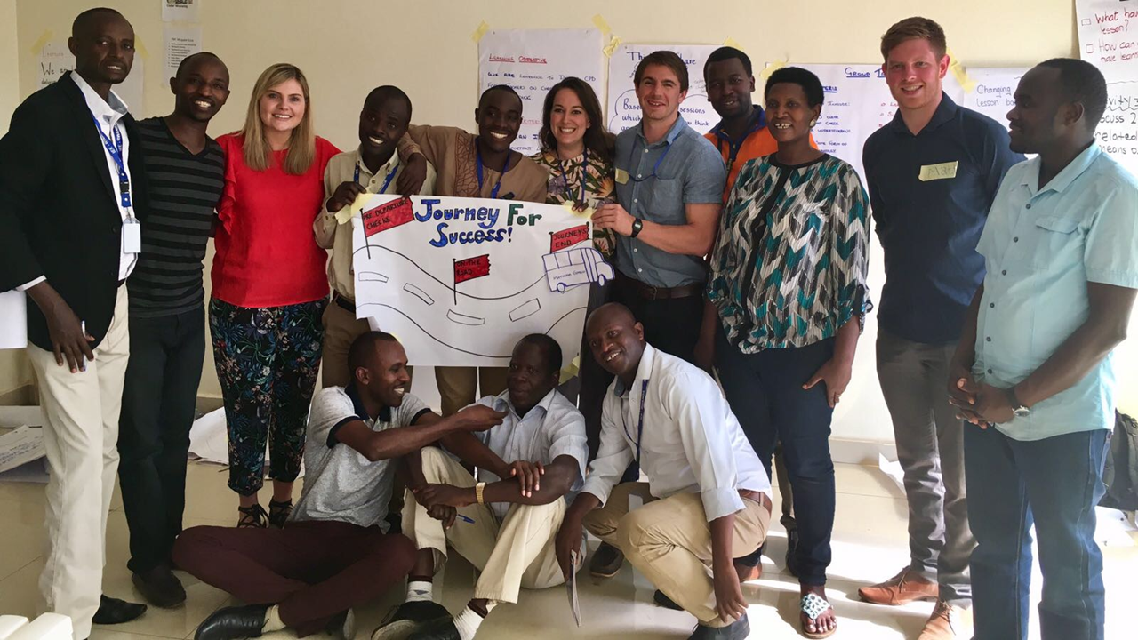

**Georgie wishes to thank you again for making new developments happen for mentors, teachers and children in Rwanda** .